|  |  |
| --- | --- |
| Purpose | To turn a ticket into a project service request |
| Participants | Information Technology staff |

# Procedure

You may be assigned a ticket that, upon investigation, is an enhancement request. Or, if a ticket is not production critical and will take 10 hours or more to resolve, it should become a project request. Be sure to follow each step below to ensure the ticket is processed by the automated project request workflow.

1. Convert a ticket into a project request
   1. Click **Reply** on the ticket.



* 1. Add a message letting the requester know you are turning their ticket into a project request and how long you estimate it will take to resolve.
  2. Click **Send**.



* 1. In the **Properties** fields on the right, change the **Type** to **Service Request**.

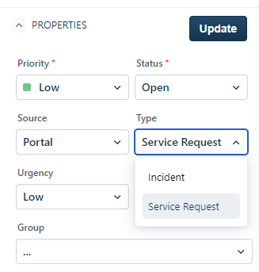

* 1. Scroll down to the bottom of the **Properties** fields.
  2. 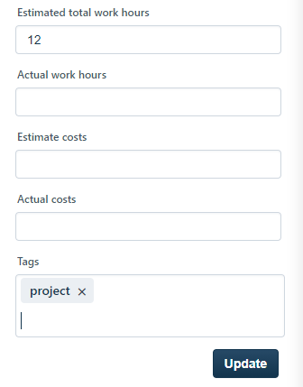Put the estimated work hours in the **Estimated Total Work Hours** field.
  3. If there is an associated cost, put the estimated cost in the **Estimated Costs** field.
  4. Put **project** in the **Tags** field.
  5. Click **Update**.

**NOTE:** The project request approval workflow automation only runs on tickets that change into Service Requests and have **project** in the **Tags** field. If you miss doing either of those at this point, the approval automation will not run.

The ticket will turn into a service request, be assigned to Ron Steen and a request for approval will be sent to the requester’s department head. The ticket’s state will change to **Project – Awaiting Management Approval**.

# Reference Material

## Related Processes

SOP-IT-037-A IT Project Request Workflow

|  |  |  |  |  |  |
| --- | --- | --- | --- | --- | --- |
| **Version** | **Date** | **Description of changes** | **Author** | **Approver** | **Status** |
| A | 2/23/2021 | Initial WI Release | Sarah Steinhoff | Ron Steen | Reviewing |
| Select |  |  |  |  | Select |
| Select |  |  |  |  | Select |
| Select |  |  |  |  | Select |
| Select |  |  |  |  | Select |